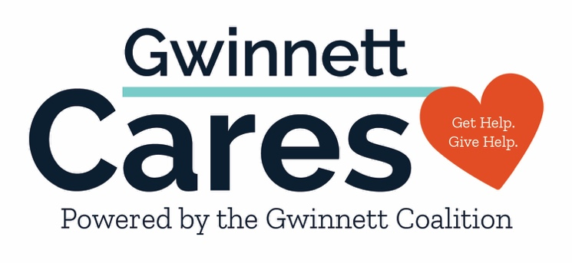

HELPING YOU STAY IN-THE-KNOW ABOUT COVID-19

WHAT TO DO IF EXPOSED COVID SYMPTOMS

WHAT TO KNOW ABOUT TESTING TEST-TO-TREAT LOCATIONS

WHAT TO DO IF POSITIVE VACCINE OPTIONS

BOOSTER OPTIONS WHERE TO GET VACCINATED

More Resources at GWINNETTCARES.ORG

